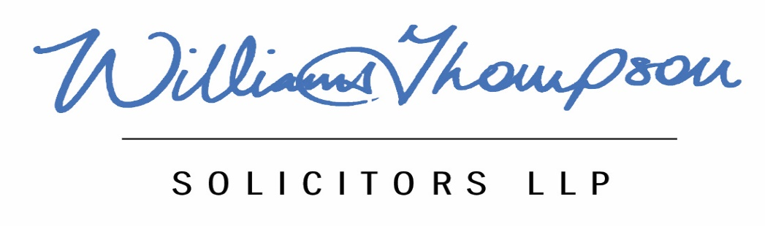

Your Personal Data

We agree to ensure that any personal data or information relating to your mediation is managed in accordance with data protection regulation. We will never share your data or information without your expressed permission excepting as is set out below. We do not share personal data or information with any third party for the purposes of direct or other marketing. We ask that you give your consent in relation to the following, which is also set out in the Agreement to Mediate :
- In the event of a complaint that is referred to my membership organisation or to any other regulator or relevant complaints handling organisation, that you agree that I may release any information or your file to either or both for the purposes of resolving any complaint.
- For the purposes of professional and quality assurance standards that my practice consultant/supervisor and/or the Legal Aid Agency may have sight of your file on a strictly controlled and confidential basis.
- That anonymised, statistical details relating to your case or outcome may be used for training and research purposes.
- That information shared with me regarding harm to you or to another person may need to be shared with the appropriate safeguarding agency. I will always seek to discuss this with you should it arise.
- I cannot keep confidentiality of information where there is an over-riding obligation in law or regulation that requires me to disclose information.
I have read and understood the above and give my consent to the arrangements set out above. I understand that I may withdraw my consent at any time and once I have notified such withdrawal to the mediator in writing.
Signed:
Please print name:
Date:

